DBMS - Mini Project Title of the Project

Submitted By: Name

SRN

V Semester Section _

# Short Description and Scope of the Project

**ER Diagram**

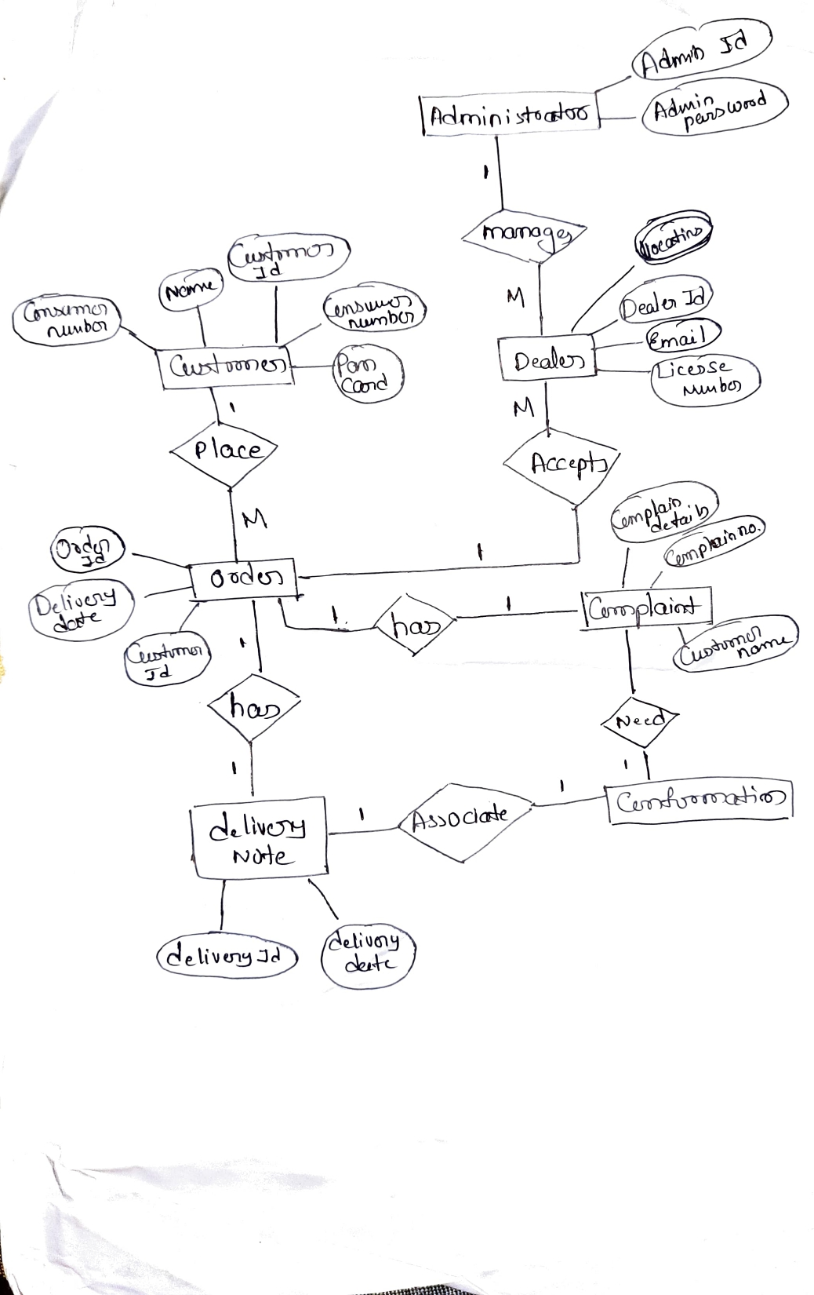

# Relational Schema

**DDL statements - Building the database**

# Populating the Database

**Join Queries**

Showcase at least 4 join queries

Write the query in English Language, Show the equivalent SQL statement and also a screenshot of the query and the results

# Aggregate Functions

Showcase at least 4 Aggregate function queries

Write the query in English Language, Show the equivalent SQL statement and also a screenshot of the query and the results

# Set Operations

Showcase at least 4 Set Operations queries

Write the query in English Language, Show the equivalent SQL statement and also a screenshot of the query and the results

# Functions and Procedures

Create a Function and Procedure. State the objective of the function / Procedure. Run and display the results.

# Triggers and Cursors

Create a Trigger and a Cursor. State the objective. Run and display the results.

# Developing a Frontend

The frontend should support

1. Addition, Modification and Deletion of records from any chosen table
2. There should be an window to accept and run any SQL statement and display the result